1. **Sign in to AWS Console:**
   * Go to the [AWS Management Console](https://aws.amazon.com/console/).
   * Sign in with your AWS credentials.
2. **Navigate to S3 Service:**
   * In the AWS Console, search for **S3** in the search bar and select **S3** from the list.

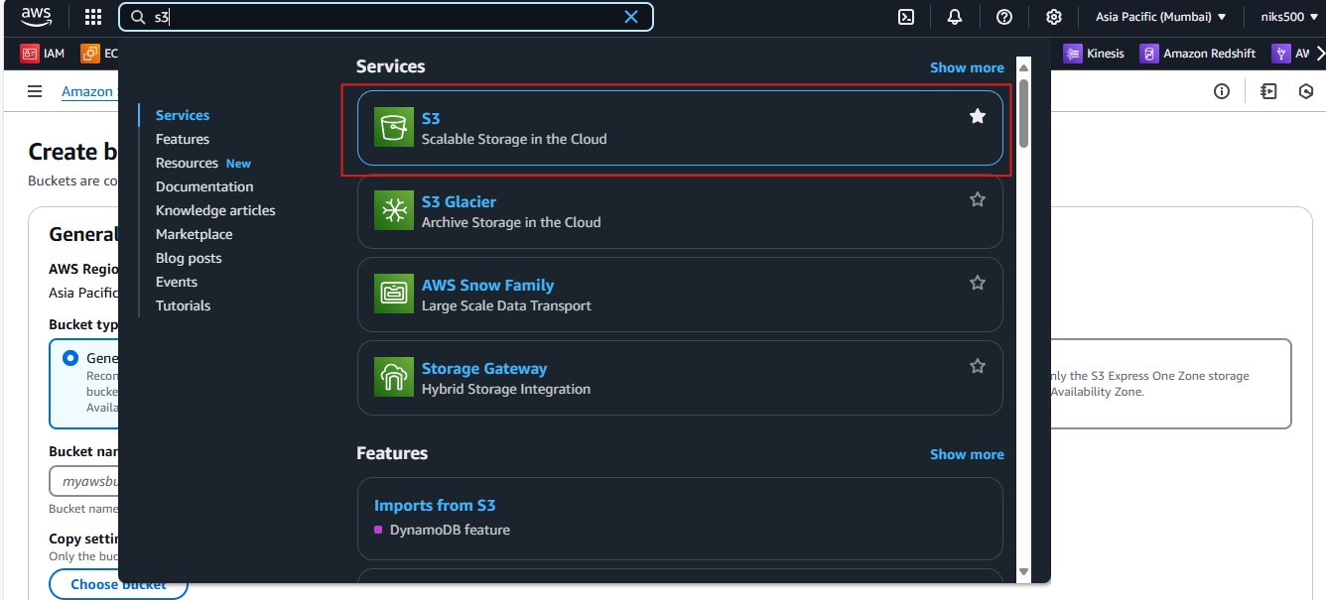

1. **Select Your Bucket:**
   * In the S3 dashboard, find and click on the name of the bucket for which you want to enable versioning.

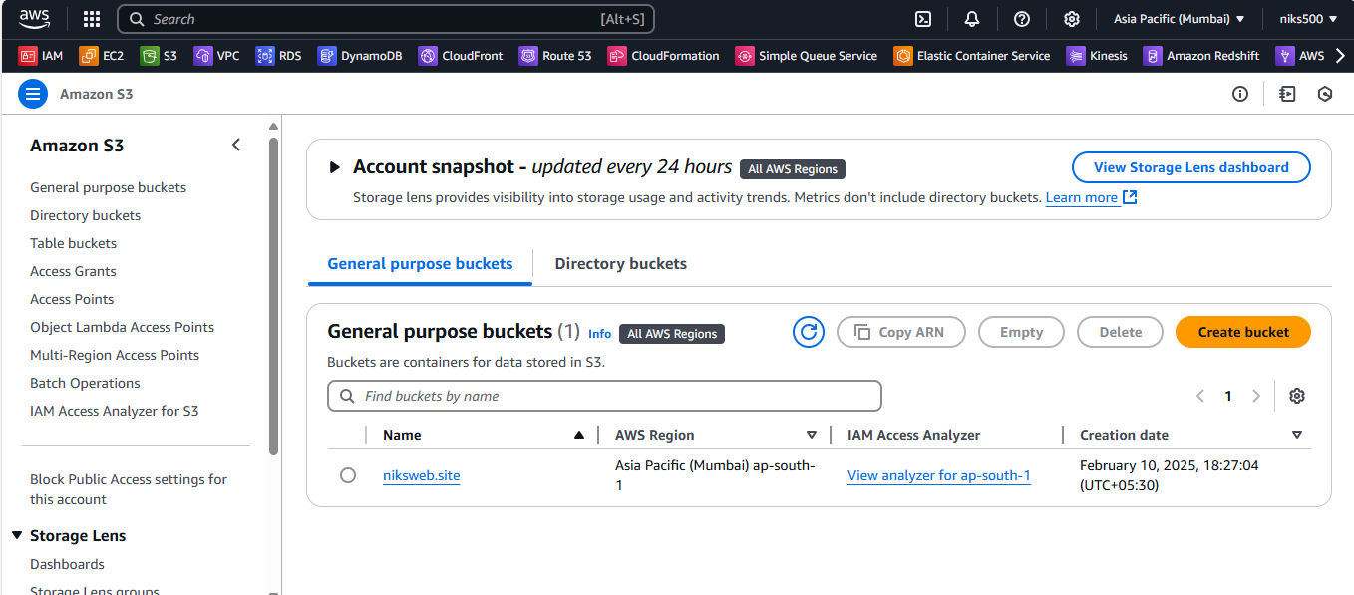

1. **Go to Bucket Properties:**
   * click on the **Properties** tab.

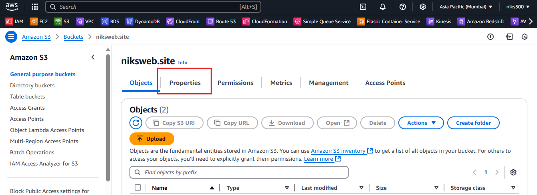

1. **Enable Versioning:**
   * Scroll down to the **Bucket Versioning** section.
   * Click **Edit** to modify the versioning settings.

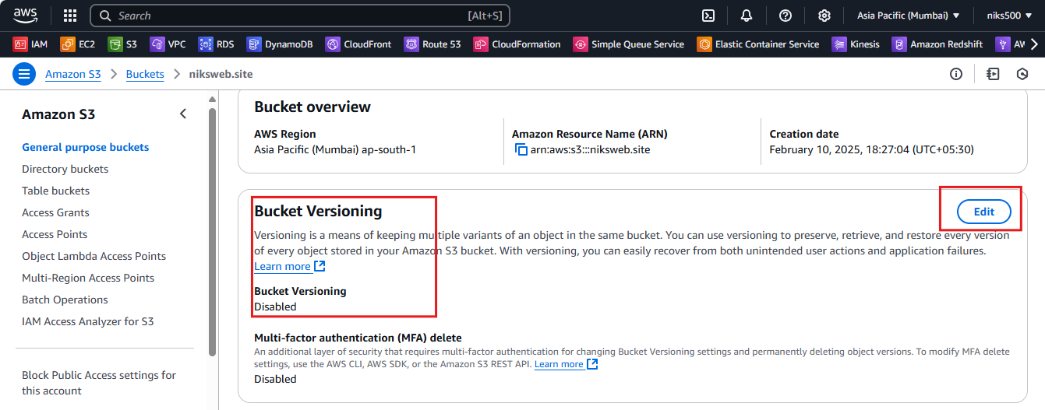

* + Select **Enable** under **Bucket Versioning**.
  + Click **Save changes**.

